**Lab Introduction:**

In this lab we’ll be learning about Routing, such as, Dynamic Routing and Static Routing, and also about RP or Routing Protocols such as RIP (Routing Information Protocol), EIGRP (Enhanced Interior Gateway Routing Protocol) and OSPF (Open Shortest Path First) and their uses. We will be implementing these protocols using Cisco Packet Tracer.

**Objectives:**

* To learn what Routing is
* How different routing works
* To learn about some RP protocols
* How these protocols work

**Index**

|  |  |  |
| --- | --- | --- |
| Experiment No. | Experiment Title | Page |
| 01 | Implementation of Dynamic Routing | 2 |
| 02 | Implementation of Static Routing | 8 |
| 03 | Implementation of Routing Information Protocol | 14 |
| 04 | Redistribution between EIGRP and OSPF | 19 |

**Experiment No.: 1**

**Experiment Title:** Implementation of Dynamic Routing.

**Objectives:**

* To learn what a Dynamic Routing is
* How a Dynamic Routing works

**Discussion:**

Routing is a process that is performed by layer 3 (or network layer) devices in order to deliver the packet by choosing an optimal path from one network to another.

There are 3 types of routing:

* Static Routing
* Default Routing
* Dynamic Routing

Of which,

Dynamic routing is the process in which only the network IP addresses are to the routing table.

Dynamic routing makes automatic adjustments of the routes according to the current state of the route in the routing table. Dynamic routing uses protocols to discover network destinations and the routes to reach them.

**Methodology:**

* Create the network topology.
* Configuration of the Network Nodes.
* Choose the Statistics.
* Run the Simulation.
* Analysis of the Results.

**Working procedure:**

1. **Giving the geometric shape of the topology**

Connecting 6 PCs to 3 switches, 2 per each, and then connecting the 3 switches to 3 routers with straight through copper cable, as they are different typed devices.

Now to connect the routers to it’s neighbouring router(s), at first we need to turn OFF the router to add “WIC-2T” network interface cards to connect the routers with “serial DCE (Data Communications Equipment)” cable. After adding “WIC-2T”, we turn ON the router.

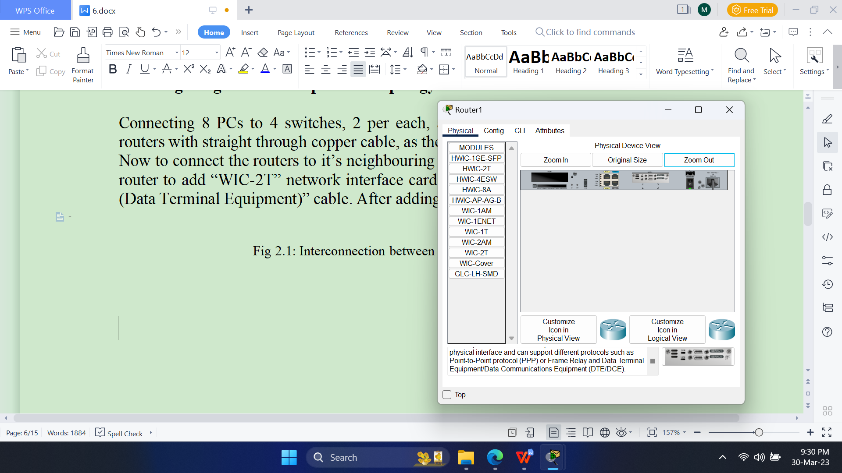

Fig 1.1: Rear view of the router after installing WIC-2T in CPT.

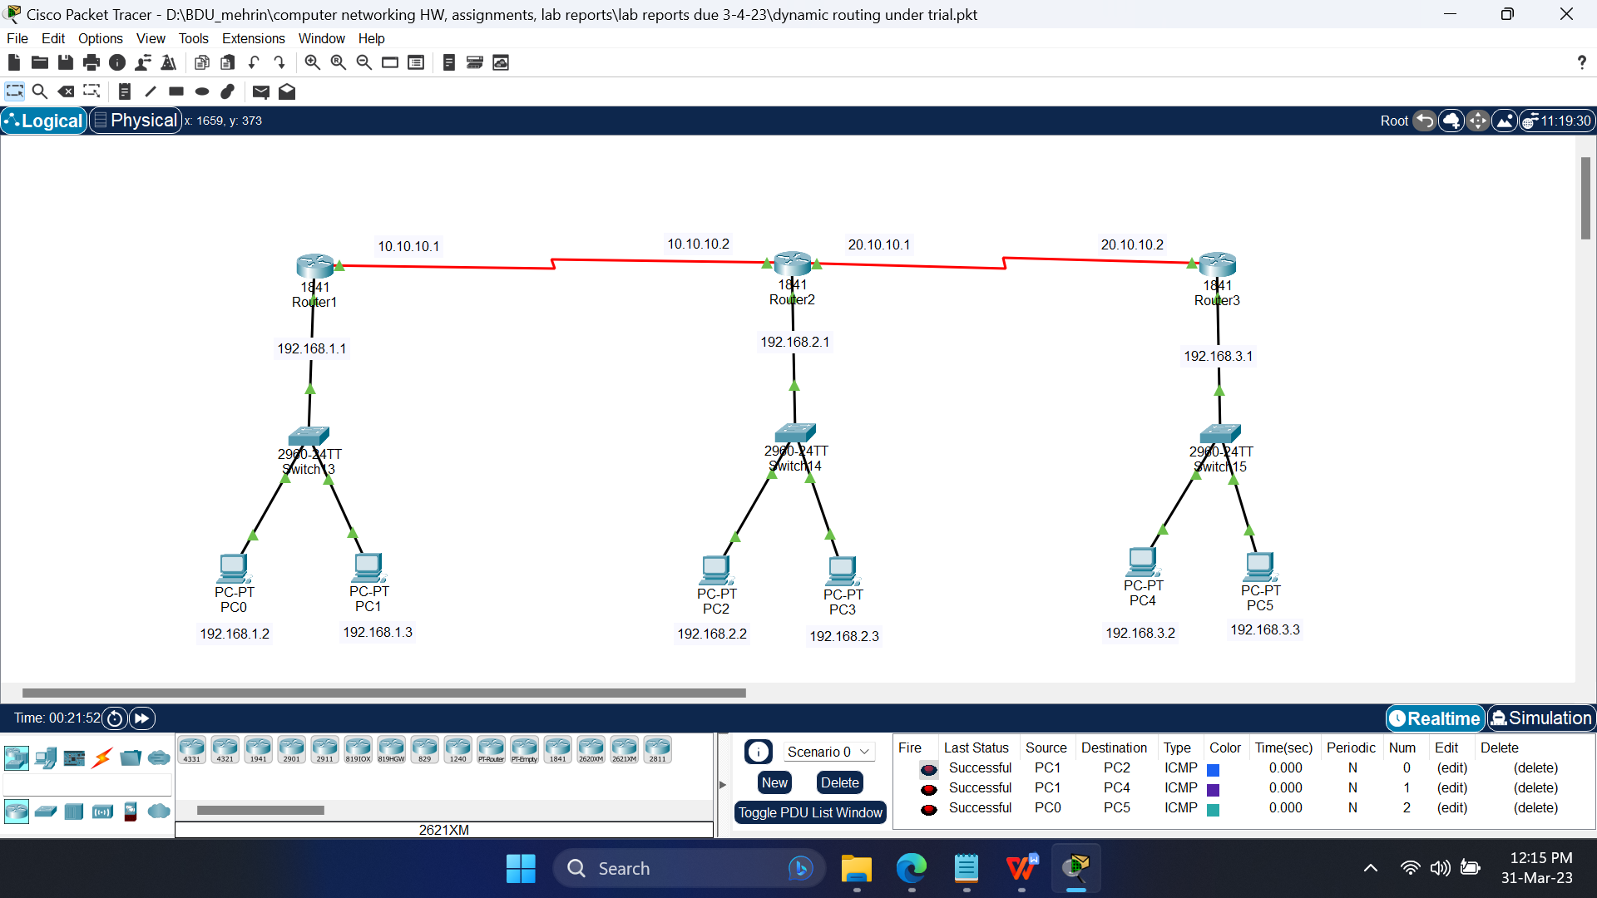

Fig 1.2: Simulating the topology using CPT.

1. **Configuring the devices**
   1. Configure the PCs with the following IP addresses and Subnet Masks

|  |  |  |  |
| --- | --- | --- | --- |
| **Host** | **IP Address** | **Subnet Mask** | **Default Gateway** |
| PC0 | 192.168.1.2 | 255.255.255.0 | 192.168.1.1 |
| PC1 | 192.168.1.3 | 255.255.255.0 | 192.168.1.1 |
| PC2 | 192.168.2.2 | 255.255.255.0 | 192.168.2.1 |
| PC3 | 192.168.2.3 | 255.255.255.0 | 192.168.2.1 |
| PC4 | 192.168.3.2 | 255.255.255.0 | 192.168.3.1 |
| PC5 | 192.168.3.3 | 255.255.255.0 | 192.168.3.1 |

* 1. Configure the routers with the following IP addresses and Subnet Masks

|  |  |  |  |
| --- | --- | --- | --- |
| **Host** | **Port** | **IP Address** | **Subnet Mask** |
| Router1 | FastEthernet0/0 | 192.168.1.1 | 255.255.255.0 |
| Serial0/0/0 | 10.10.10.1 | 255.0.0.0 |
| Router2 | FastEthernet0/0 | 192.168.2.1 | 255.255.255.0 |
| Serial0/0/0 | 10.10.10.2 | 255.0.0.0 |
| Serial0/0/1 | 20.10.10.1 | 255.0.0.0 |
| Router3 | FastEthernet0/0 | 192.168.3.1 | 255.255.255.0 |
| Serial0/0/0 | 20.10.10.2 | 255.0.0.0 |

* 1. Configure the RIP routing of the routers by adding the following Network IP addresses

|  |  |
| --- | --- |
| **Host** | **Network IP Addresses** |
| Router1 | 192.168.1.0 |
| 192.168.2.0 |
| 192.168.3.0 |
| 10.0.0.0 |
| 20.0.0.0 |
| Router2 | 192.168.1.0 |
| 192.168.2.0 |
| 192.168.3.0 |
| 10.0.0.0 |
| 20.0.0.0 |
| Router3 | 192.168.1.0 |
| 192.168.2.0 |
| 192.168.3.0 |
| 10.0.0.0 |
| 20.0.0.0 |

1. **Sending data across PCs**
   1. Connection tests across PCs

Ping PCs by there IP addresses from another PC in Command Prompt. If connection is there, four replies will come.

Command: ping<space>’IP address of some other PC’

For first time communication, some packets may be lost.

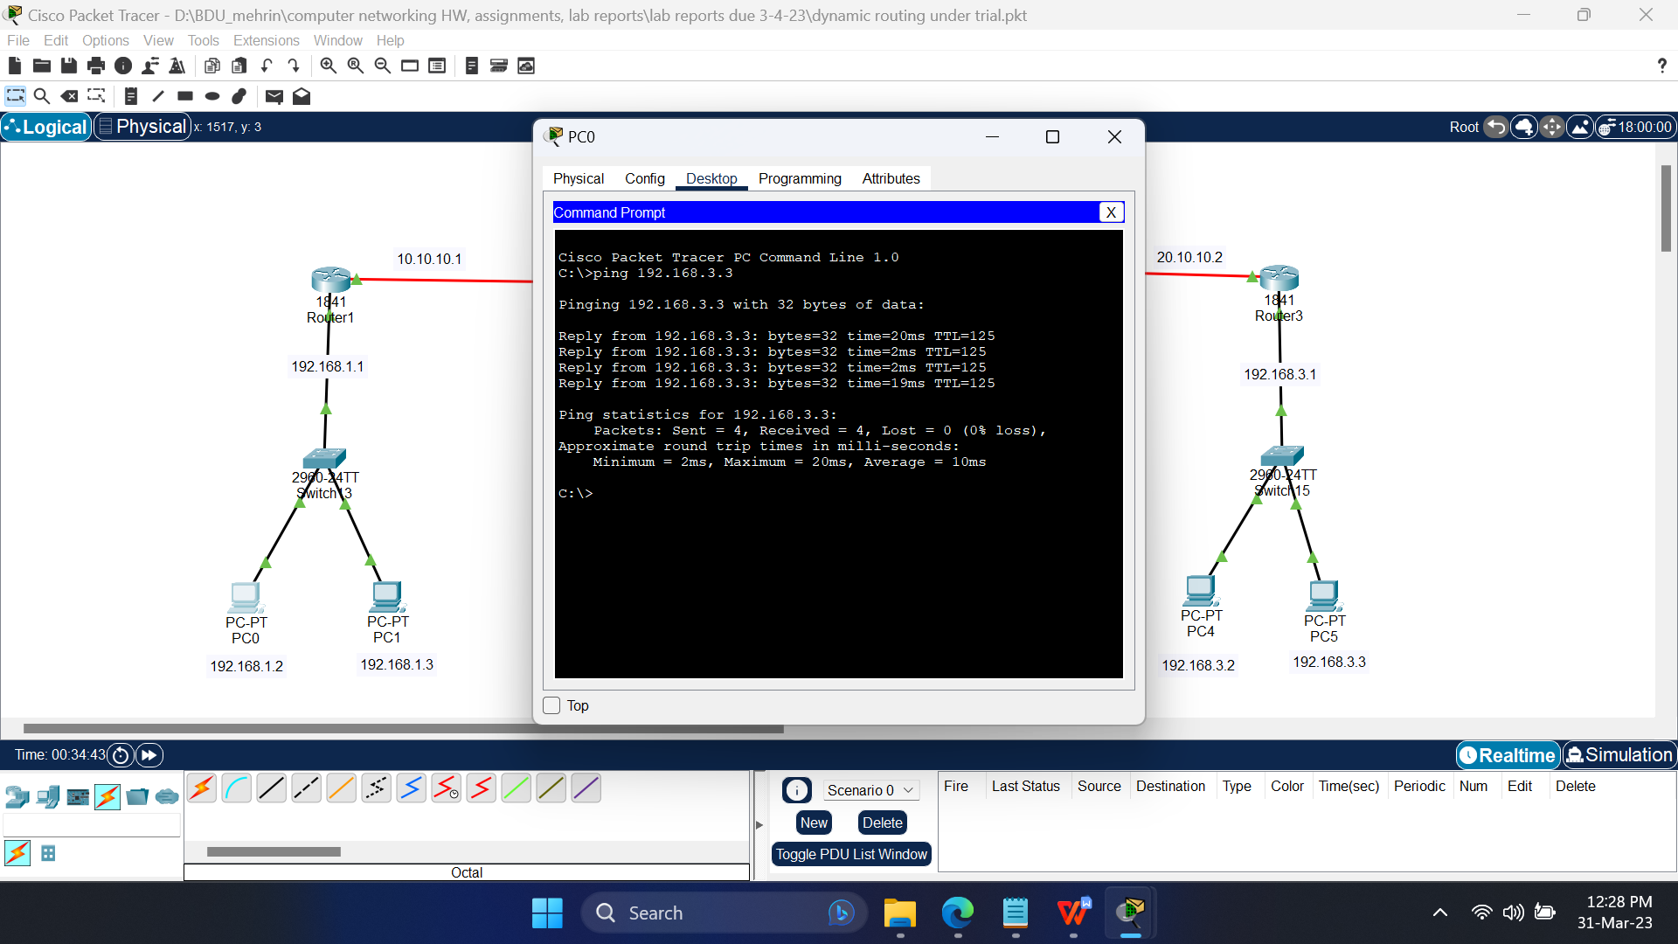

Fig 1.3: Pinging PC5 from PC0

**Simulation:**

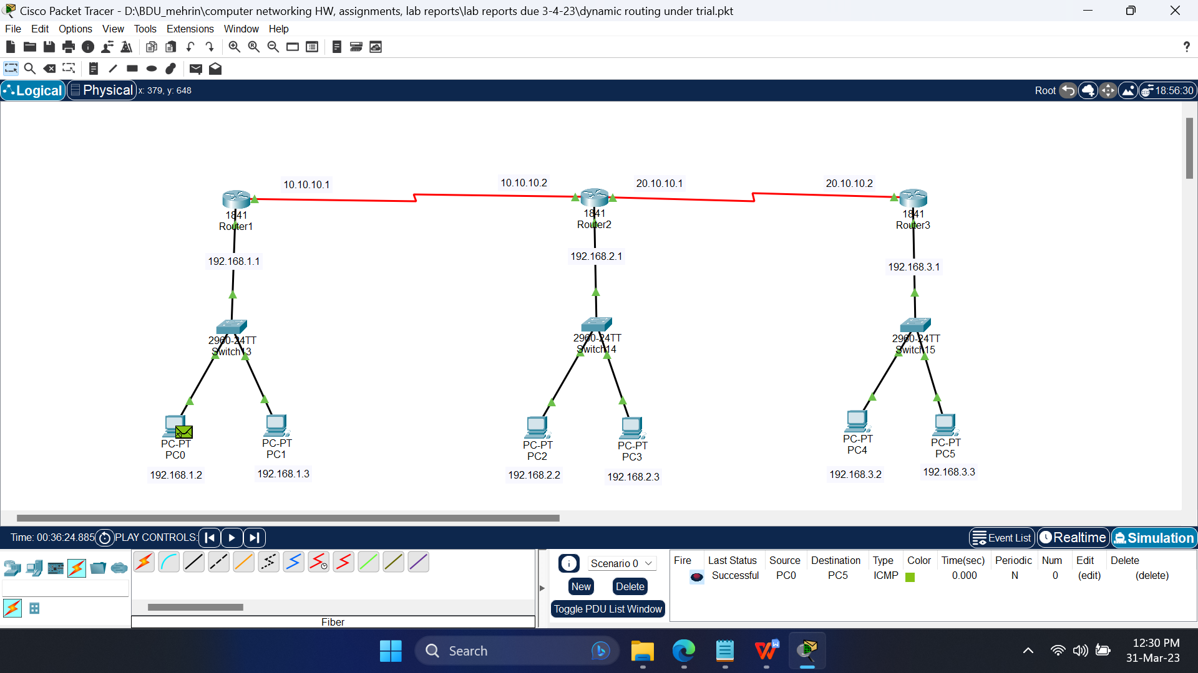

Fig 1.4: Successful packets travel across PCs

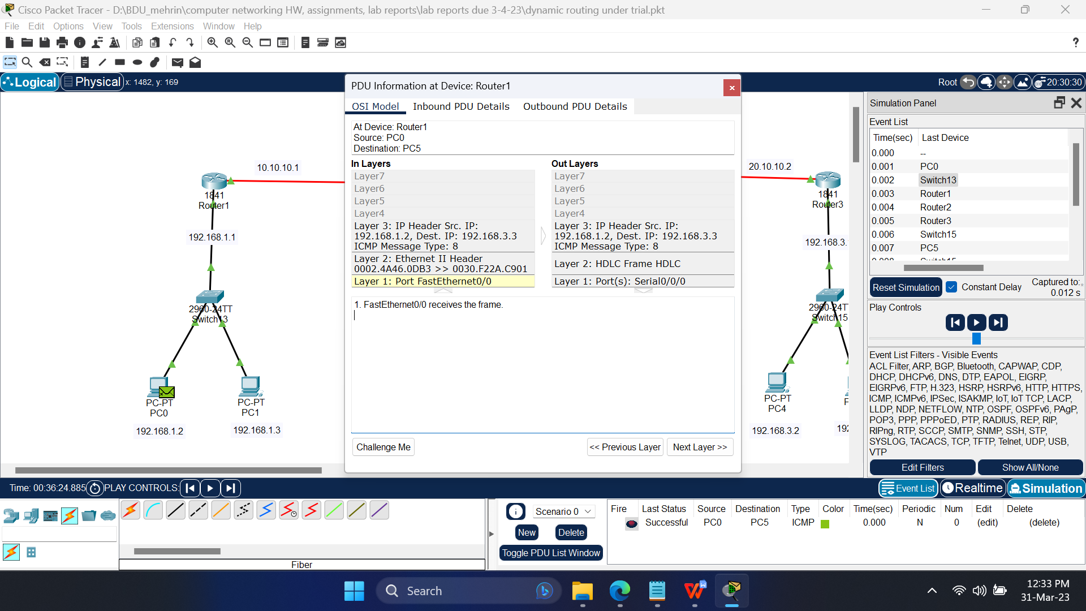

Fig 1.5: PDU information at the OSI model at Router1

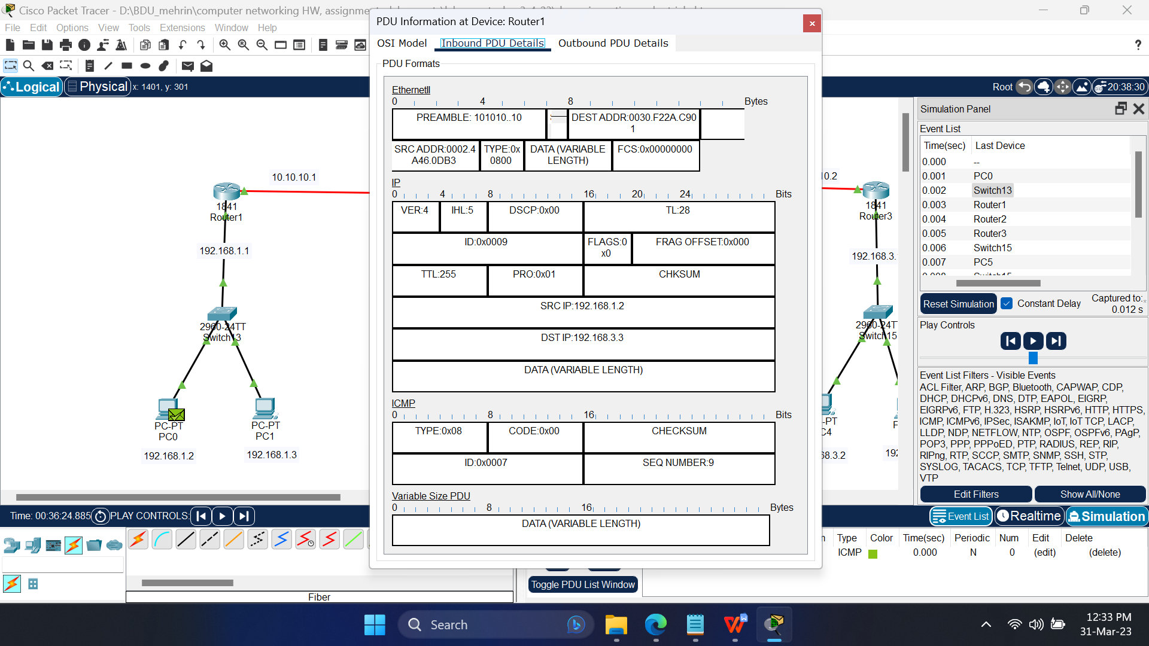

Fig 1.6: Inbound Protocol data unit details at Router0

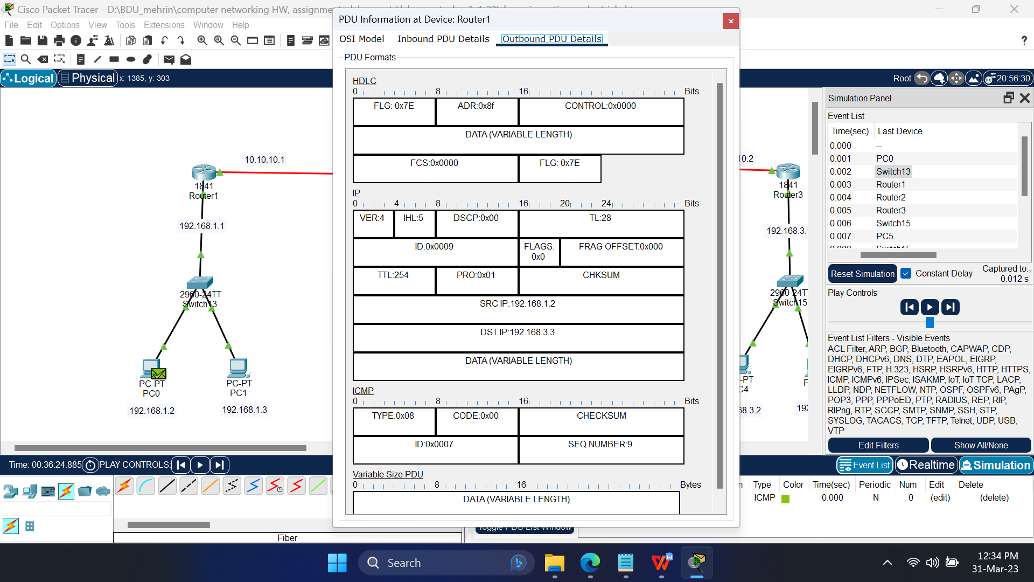

Fig 1.7: Outbound Protocol data unit details at Router0

**Conclusion:**

In Dynamic routing, only the network IP addresses are added to the routing table.

Dynamic routing uses protocols to discover network destinations and the routes to reach them. It also requires more bandwidth.

Caution:

* While configuring the serial ports of the routers, as they will be connected to different networks, just having different host part of the IP addresses will not work, it will still overlap with the other network. Therefore, the network part of the IP address must also be different.

**Experiment No.: 2**

**Experiment Title:** Implementation of Static Routing.

**Objectives:**

* To learn what a Static Routing is
* How a Static Routing works

**Discussion:**

Routing is a process that is performed by layer 3 (or network layer) devices in order to deliver the packet by choosing an optimal path from one network to another.

There are 3 types of routing:

* Static Routing
* Default Routing
* Dynamic Routing

Of which,

Static routing is the process in which the routes are added manually to the routing table.

**Methodology:**

* Create the network topology.
* Configuration of the Network Nodes.
* Choose the Statistics.
* Run the Simulation.
* Analysis of the Results.

**Working procedure:**

1. **Giving the geometric shape of the topology**

Connecting 8 PCs to 4 switches, 2 per each, and then connecting the 4 switches to 4 routers with straight through copper cable, as they are different typed devices.

Now to connect the routers to it’s neighbouring router(s), at first we need to turn OFF the router to add “WIC-2T” network interface cards to connect the routers with “serial DTE (Data Terminal Equipment)” cable. After adding “WIC-2T”, we turn ON the router.



Fig 2.1: Rear view of the router after installing WIC-2T in CPT.

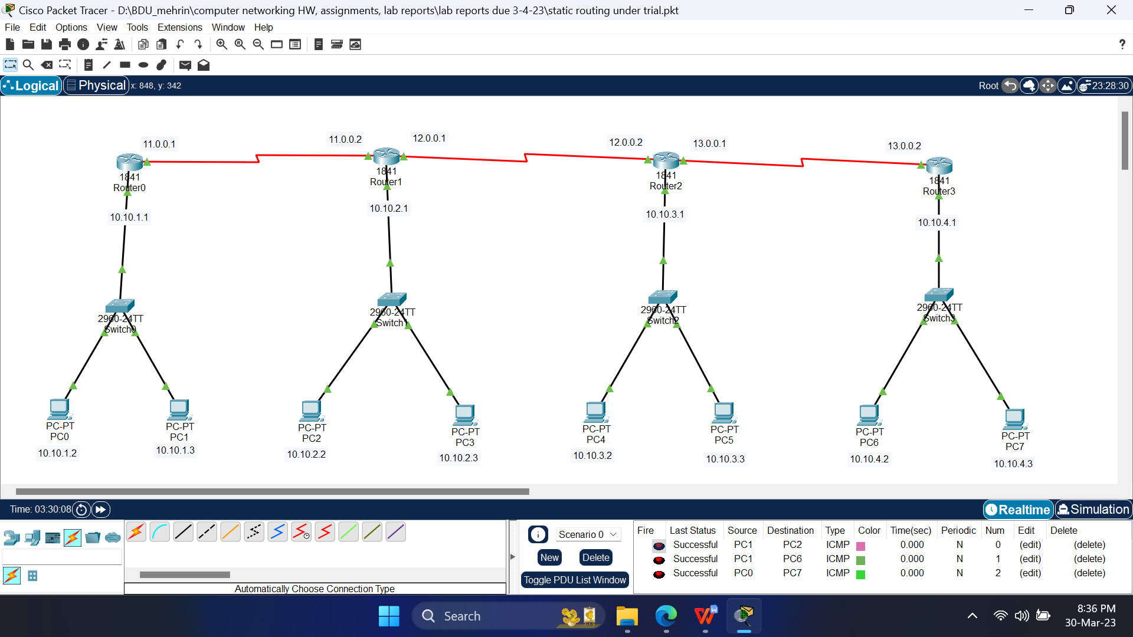

Fig 2.2: Simulating the topology using CPT.

1. **Configuring the devices**
   1. Configure the PCs with the following IP addresses and Subnet Masks

|  |  |  |  |
| --- | --- | --- | --- |
| **Host** | **IP Address** | **Subnet Mask** | **Default Gateway** |
| PC0 | 10.10.1.2 | 255.0.0.0 | 10.10.1.1 |
| PC1 | 10.10.1.3 | 255.0.0.0 | 10.10.1.1 |
| PC2 | 10.10.2.2 | 255.0.0.0 | 10.10.2.1 |
| PC3 | 10.10.2.3 | 255.0.0.0 | 10.10.2.1 |
| PC4 | 10.10.3.2 | 255.0.0.0 | 10.10.3.1 |
| PC5 | 10.10.3.3 | 255.0.0.0 | 10.10.3.1 |
| PC6 | 10.10.4.2 | 255.0.0.0 | 10.10.4.1 |
| PC7 | 10.10.4.3 | 255.0.0.0 | 10.10.4.1 |

* 1. Configure the routers with the following IP addresses and Subnet Masks

|  |  |  |  |
| --- | --- | --- | --- |
| **Host** | **Port** | **IP Address** | **Subnet Mask** |
| Router0 | FastEthernet0/0 | 10.10.1.1 | 255.0.0.0 |
| Serial0/0/0 | 11.0.0.1 | 255.0.0.0 |
| Router1 | FastEthernet0/0 | 10.10.2.1 | 255.0.0.0 |
| Serial0/0/0 | 11.0.0.2 | 255.0.0.0 |
| Serial0/0/1 | 12.0.0.1 | 255.0.0.0 |
| Router2 | FastEthernet0/0 | 10.10.3.1 | 255.0.0.0 |
| Serial0/0/0 | 12.0.0.2 | 255.0.0.0 |
| Serial0/0/1 | 13.0.0.1 | 255.0.0.0 |
| Router3 | FastEthernet0/0 | 10.10.4.1 | 255.0.0.0 |
| Serial0/0/0 | 13.0.0.2 | 255.0.0.0 |

* 1. Configure the static routes of the routers with the following Network IP addresses and Subnet Masks and Next Hop IP addresses

|  |  |  |  |  |
| --- | --- | --- | --- | --- |
| **Host** | **#Route** | **Network IP** | **Subnet Mask** | **Next Hop’s IP** |
| Router0 | 1 | 12.0.0.0 | 255.0.0.0 | 11.0.0.2 |
| 2 | 13.0.0.0 | 255.0.0.0 | 12.0.0.2 |
| 3 | 10.10.2.0 | 255.255.255.0 | 11.0.0.2 |
| 4 | 10.10.4.0 | 255.255.255.0 | 11.0.0.2 |
| 5 | 10.10.3.0 | 255.255.255.0 | 11.0.0.2 |
| Router1 | 1 | 13.0.0.0 | 255.0.0.0 | 12.0.0.2 |
| 2 | 10.10.1.0 | 255.255.255.0 | 11.0.0.1 |
| 3 | 10.10.3.0 | 255.255.255.0 | 12.0.0.2 |
| 4 | 10.10.4.0 | 255.255.255.0 | 12.0.0.2 |
| Router2 | 1 | 11.0.0.0 | 255.0.0.0 | 12.0.0.1 |
| 2 | 10.10.1.0 | 255.255.255.0 | 12.0.0.1 |
| 3 | 10.10.2.0 | 255.255.255.0 | 12.0.0.1 |
| 4 | 10.10.4.0 | 255.255.255.0 | 13.0.0.2 |
| Router3 | 1 | 11.0.0.0 | 255.0.0.0 | 12.0.0.1 |
| 2 | 12.0.0.0 | 255.0.0.0 | 13.0.0.1 |
| 3 | 10.10.1.0 | 255.255.255.0 | 13.0.0.1 |
| 4 | 10.10.2.0 | 255.255.255.0 | 13.0.0.1 |
| 5 | 10.10.3.0 | 255.255.255.0 | 13.0.0.1 |

1. **Sending data across PCs**
   1. Connection tests across PCs

Ping PCs by there IP addresses from another PC in Command Prompt. If connection is there, four replies will come.

Command: ping<space>’IP address of some other PC’

For first time communication, some packets may be lost.

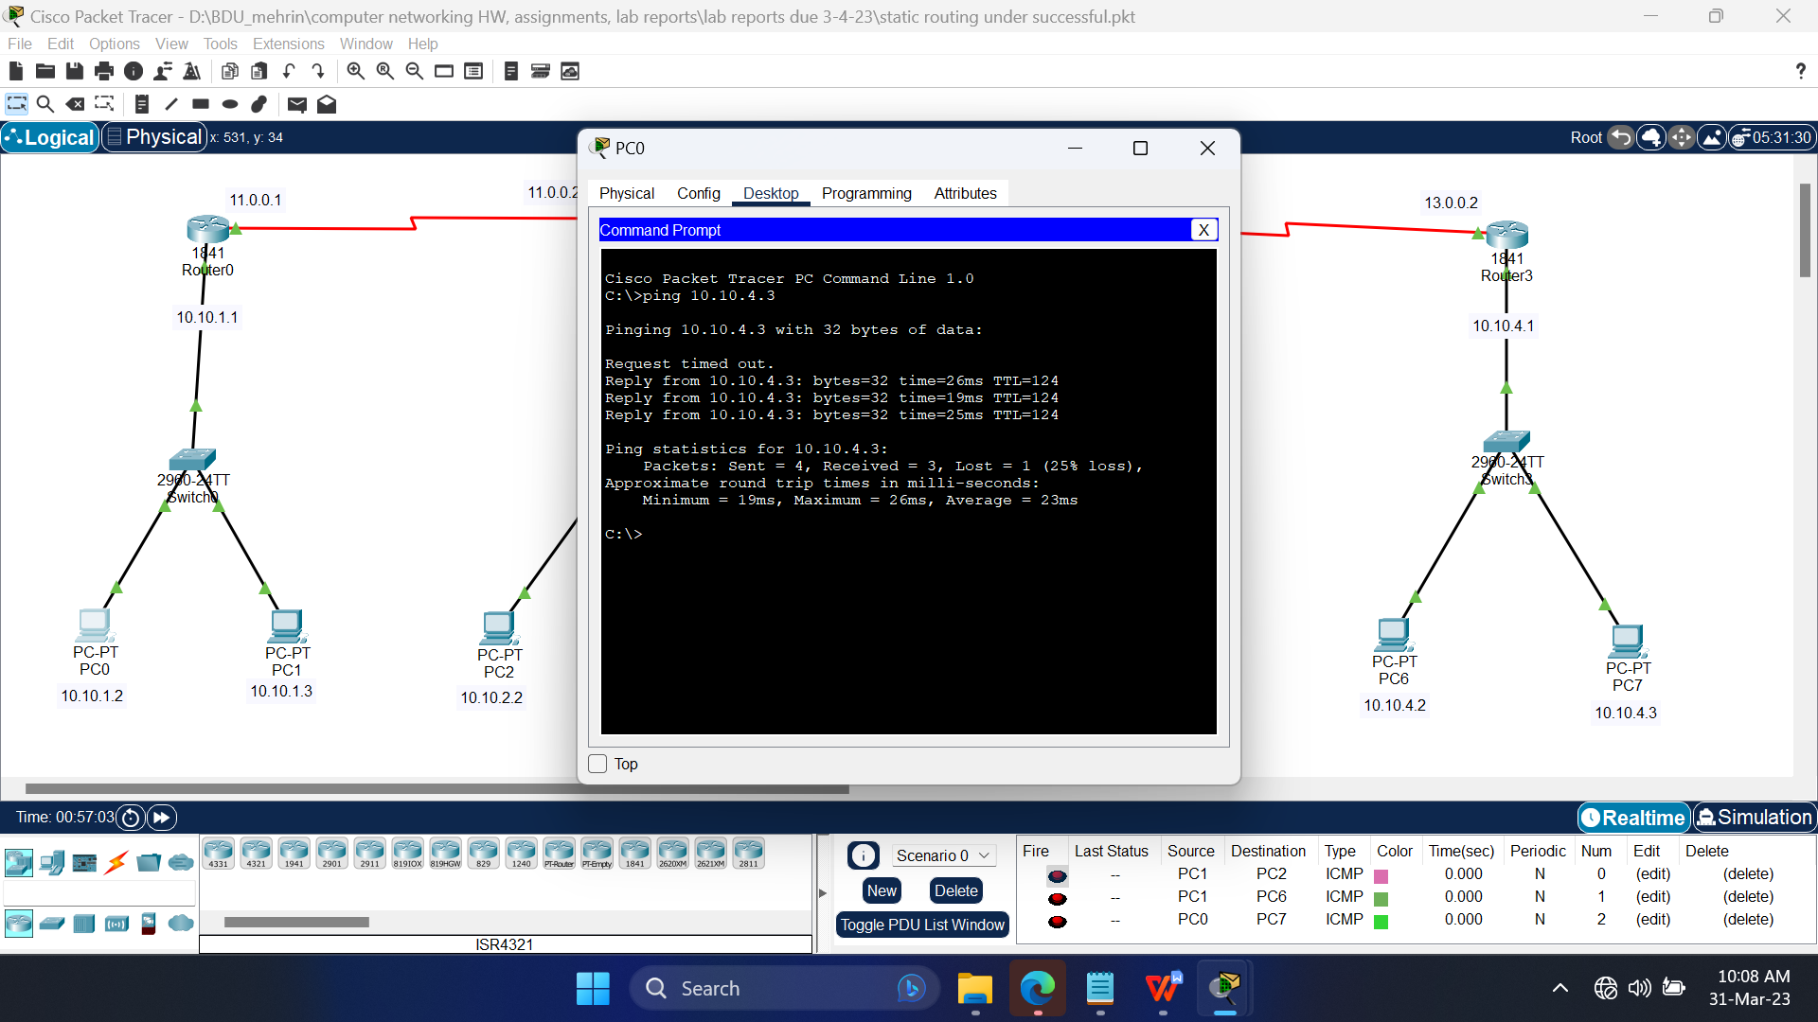

Fig 2.3: Pinging PC7 from PC0

1. **Simulation:**

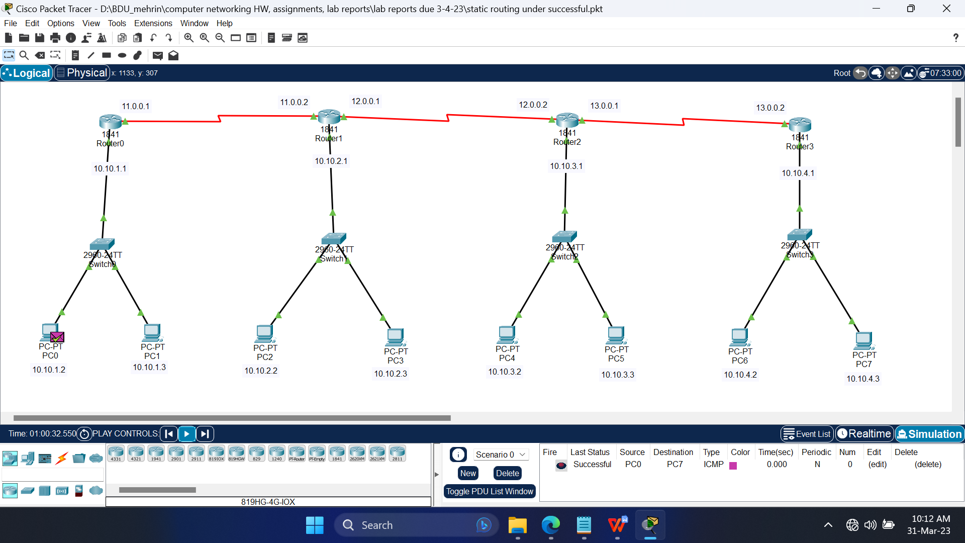

Fig 2.4: Successful packets travel across PCs

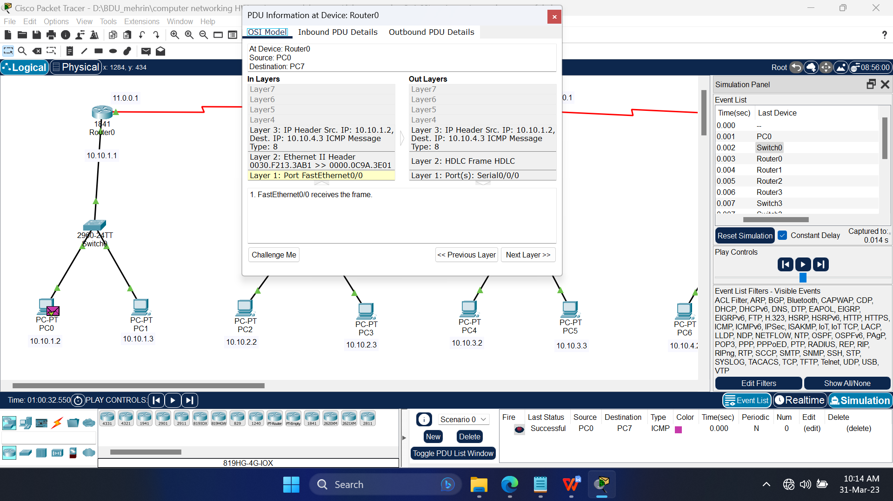

Fig 2.5: PDU information at the OSI model in Router0

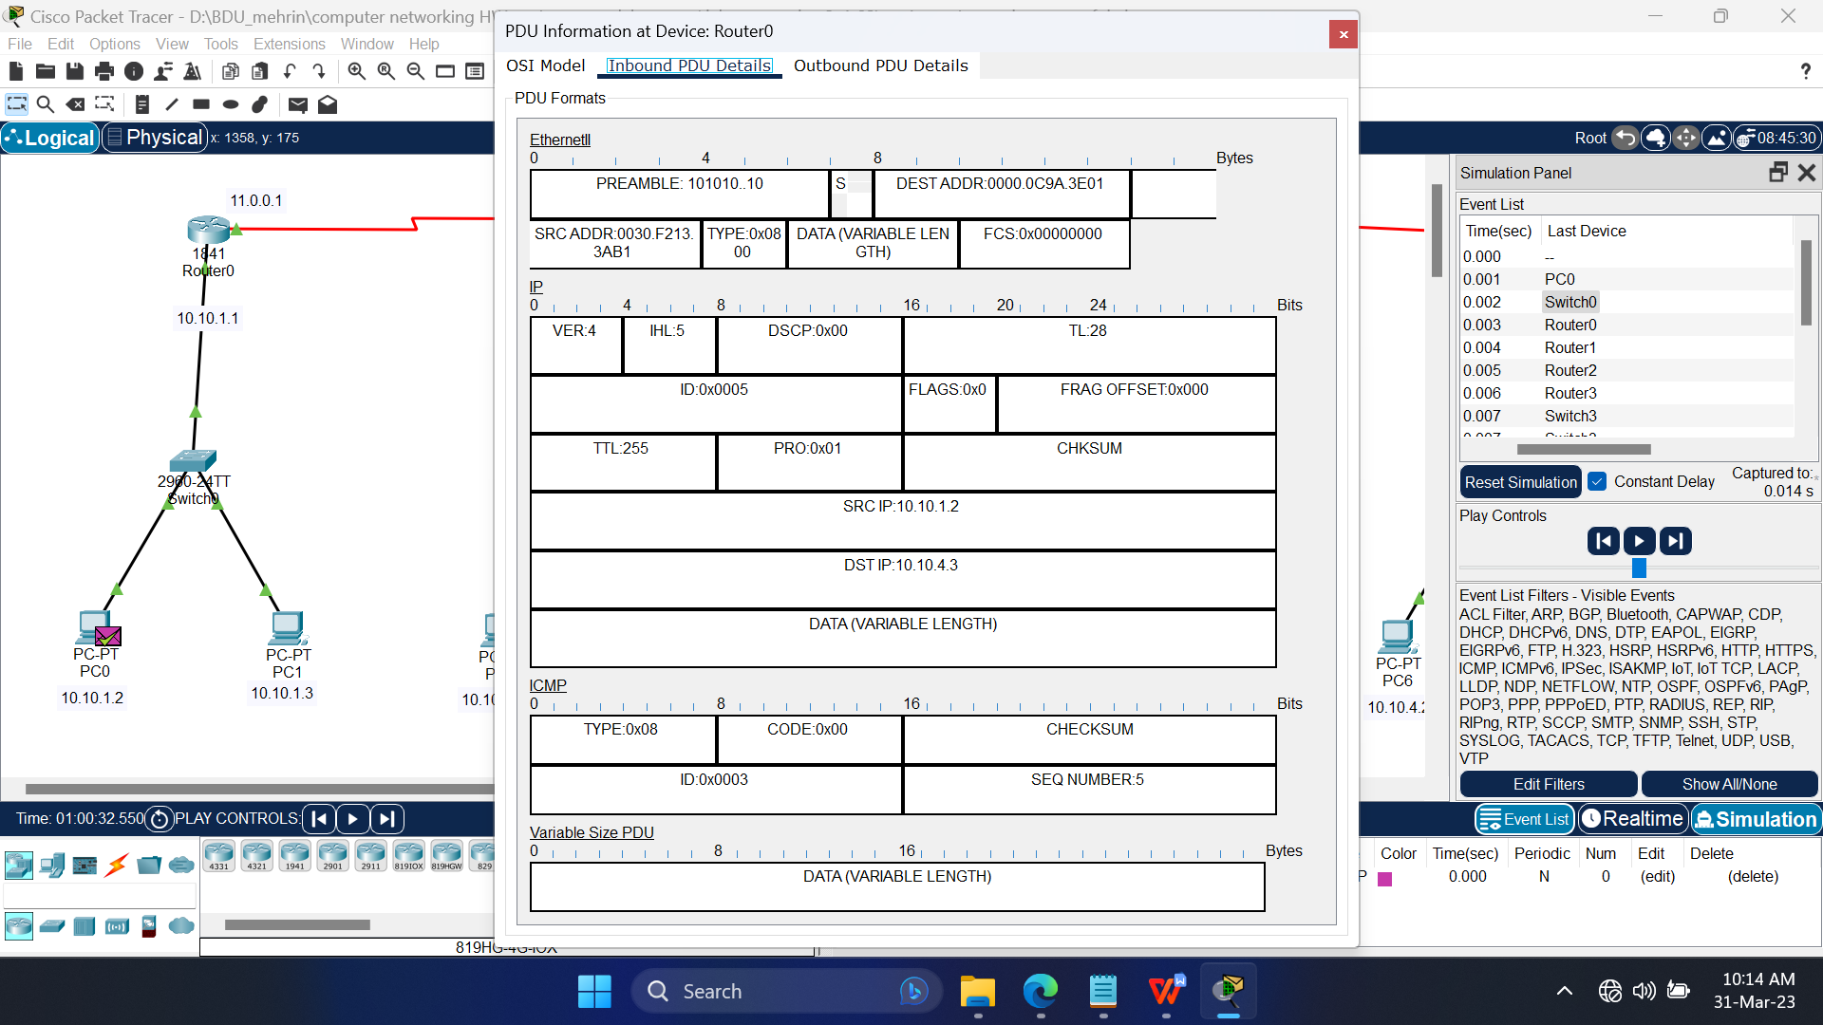

Fig 2.6: Inbound Protocol data unit details at Router0

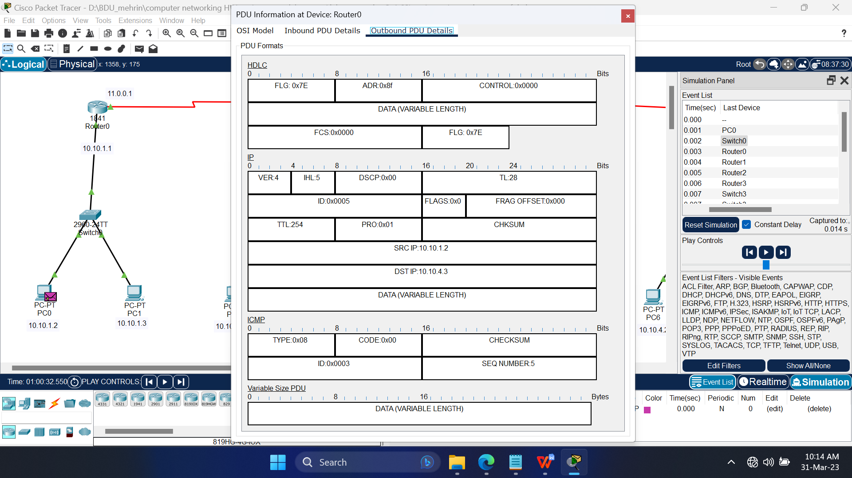

Fig 2.7: Outbound Protocol data unit details at Router0

**Conclusion:**

In Static routing, routes are added manually to the routing table, which is a hectic task for a big network. Also the network administrator needs to know the topology very well to add the routes,static routes are fixed and do not change if the network topology changes. [Static routing is useful for small networks that have only one or two routers or where network traffic is predictable and stable](https://en.wikipedia.org/wiki/Static_routing" \t "https://www.bing.com/_blank).

Caution:

* While configuring the serial ports of the routers, as they will be connected to different networks, just having different host part of the IP addresses will not work, it will still overlap with the other network. Therefore, the network part of the IP address must also be different.

**Experiment No.: 3**

**Experiment Title:** Implementation of Routing Information Protocol.

**Objectives:**

* To learn what Routing Information Protocol is
* How a Routing Information Protocol works

**Discussion:**

Routing is a process that is performed by layer 3 (or network layer) devices in order to deliver the packet by choosing an optimal path from one network to another.

There are 3 types of routing:

* Static Routing
* Default Routing
* Dynamic Routing

Routing Information Protocol (RIP) is a dynamic routing protocol that uses hop count as a routing metric to find the best path between the source and the destination.

**Methodology:**

* Create the network topology.
* Configuration of the Network Nodes.
* Choose the Statistics.
* Run the Simulation.
* Analysis of the Results.

**Working procedure:**

1. **Giving the geometric shape of the topology**

Connecting 2 PCs to 2 switches, 1 per each, and then connecting the 2 switches to 2 routers, 1 per each, with straight through copper cable, as they are different typed devices.

Now connect the routers with “serial DCE (Data Communications Equipment)” cable.

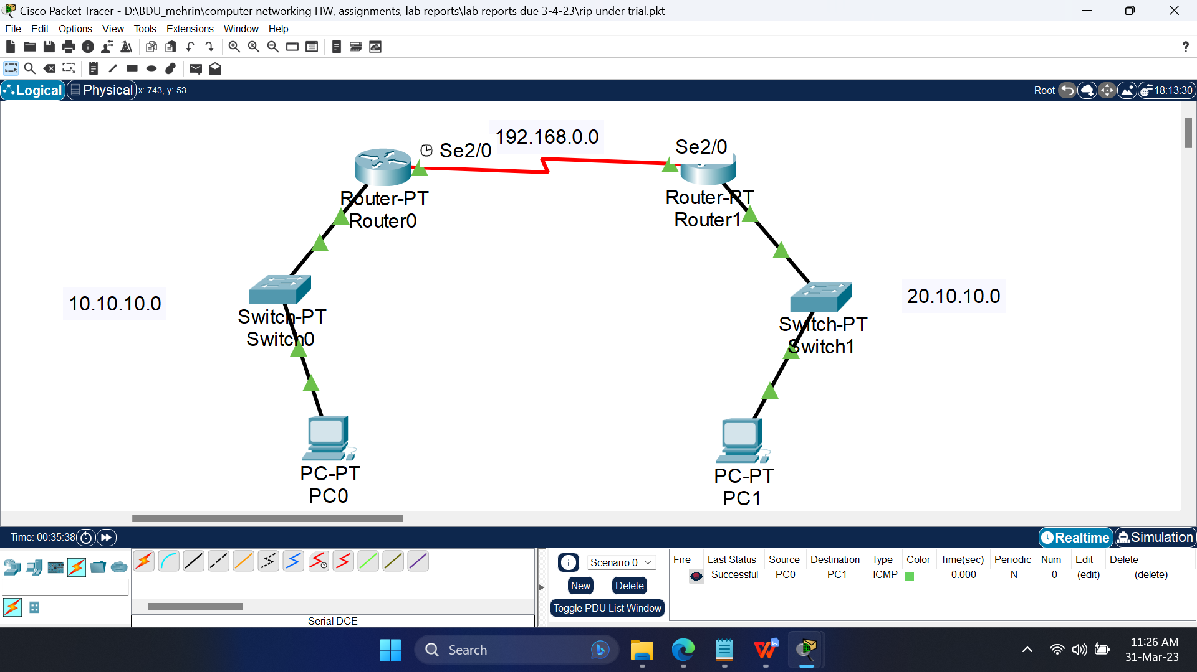

Fig 3.1: Simulating the topology using CPT.

1. **Configuring the devices**
   1. Configure the PCs with the following IP addresses and Subnet Masks

|  |  |  |  |
| --- | --- | --- | --- |
| **Host** | **IP Address** | **Subnet Mask** | **Default Gateway** |
| PC0 | 10.10.10.1 | 255.0.0.0 | 10.10.10.0 |
| PC1 | 20.10.10.1 | 255.0.0.0 | 20.10.10.0 |

* 1. Configure the routers with the following IP addresses and Subnet Masks

|  |  |  |  |
| --- | --- | --- | --- |
| **Host** | **Port** | **IP Address** | **Subnet Mask** |
| Router0 | FastEthernet0/0 | 10.10.10.0 | 255.0.0.0 |
| Serial2/0 | 192.168.0.1 | 255.255.255.0 |
| Router1 | FastEthernet0/0 | 20.10.10.0 | 255.0.0.0 |
| Serial2/0 | 192.168.0.2 | 255.255.255.0 |

* 1. Configure the RIP routing of the routers by adding the following Network IP addresses

|  |  |
| --- | --- |
| **Host** | **Network IP** |
| Router0 | 10.10.10.0 |
| 20.10.10.0 |
| 192.168.0.0 |
| Router1 | 10.10.10.0 |
| 20.10.10.0 |
| 192.168.0.0 |

Also, set the clock rate of the port Serial2/0 of Router0 to 64000

And set the clock rate of the port Serial2/0 of Router0 to “Not set”.

1. **Sending data across PCs**
   1. Connection tests across PCs

Ping PCs by there IP addresses from another PC in Command Prompt. If connection is there, four replies will come.

Command: ping<space>’IP address of some other PC’

For first time communication, some packets may be lost.

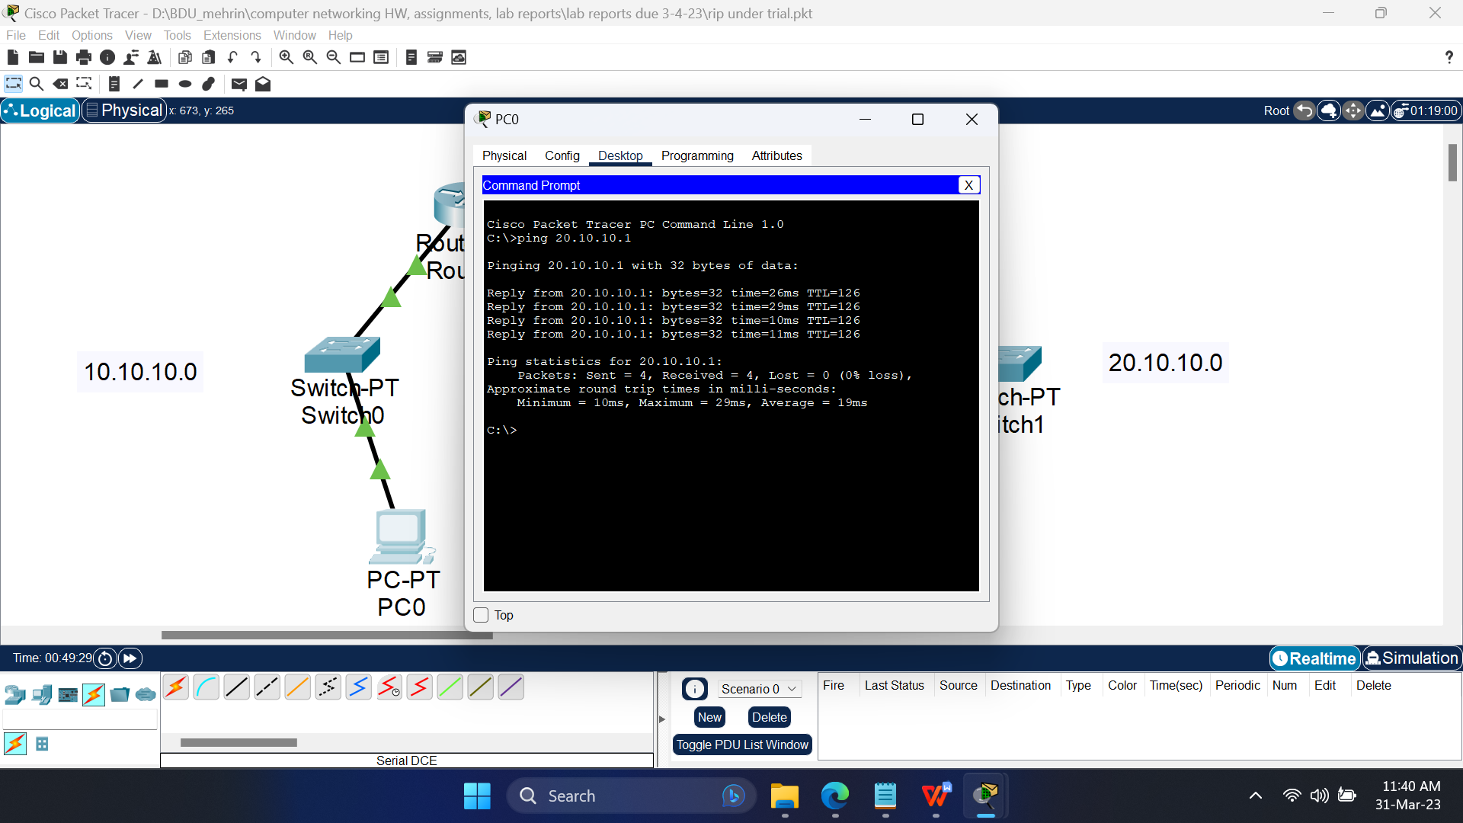

Fig 3.2: Pinging PC1 from PC0

**Simulation:**

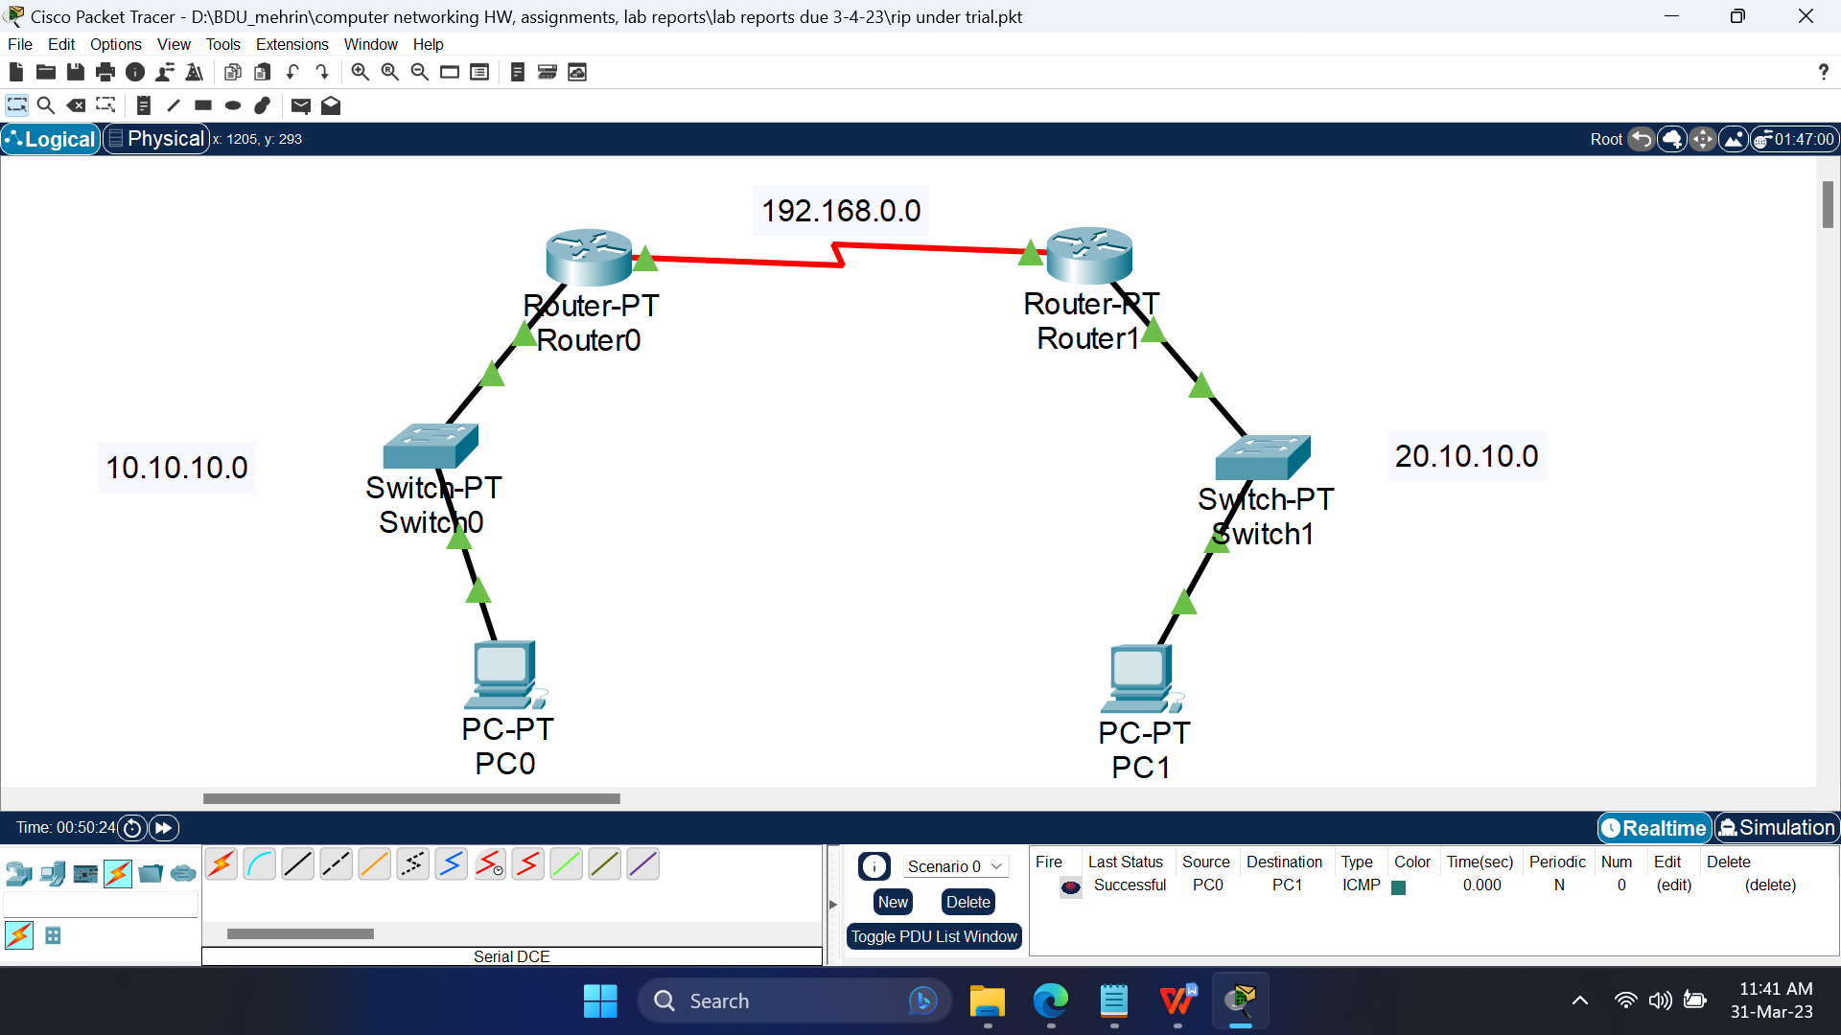

Fig 3.3: Successful packets travel across PCs

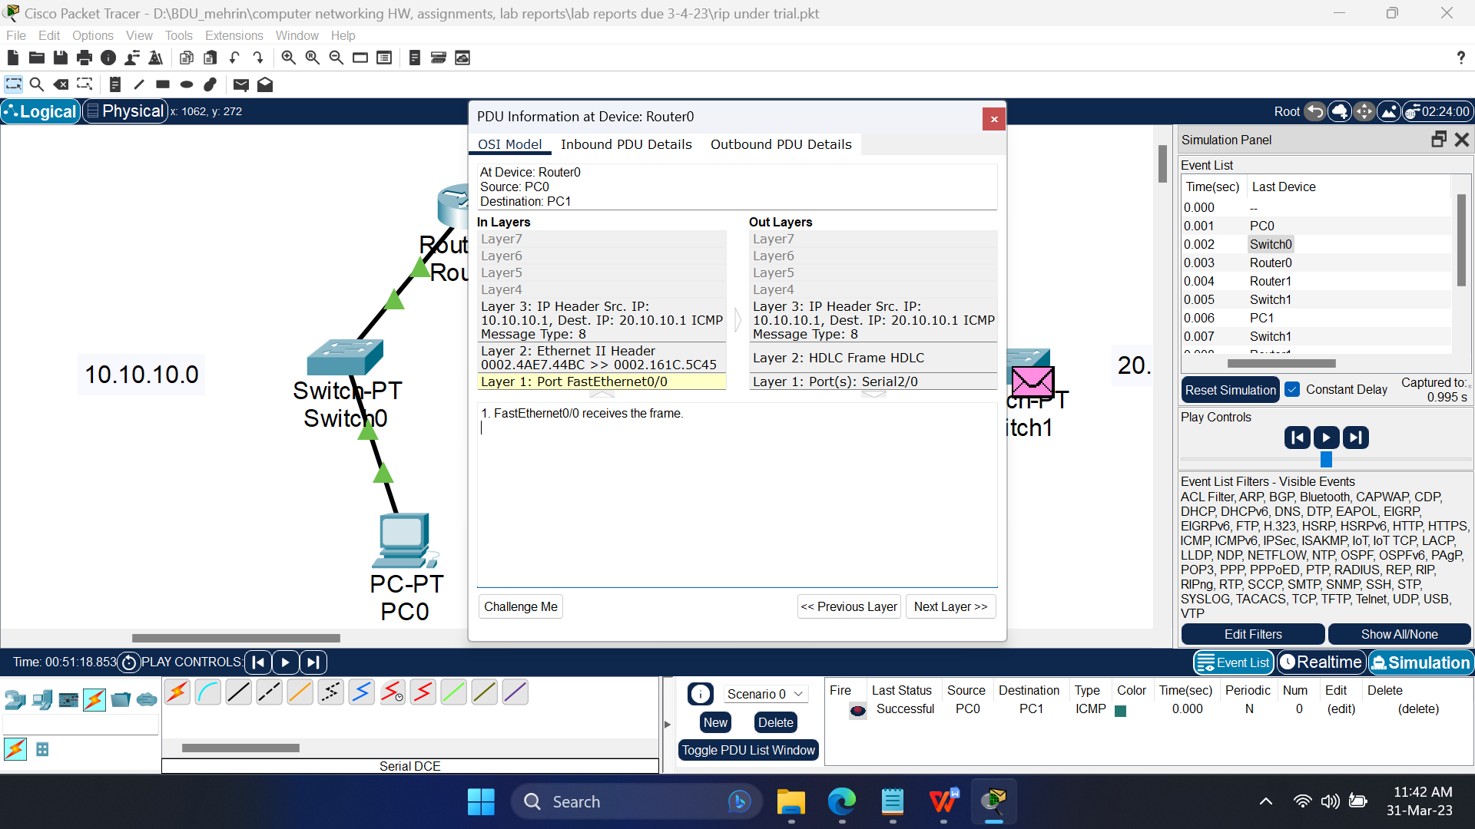

Fig 3.4: PDU information at the OSI model at Router0

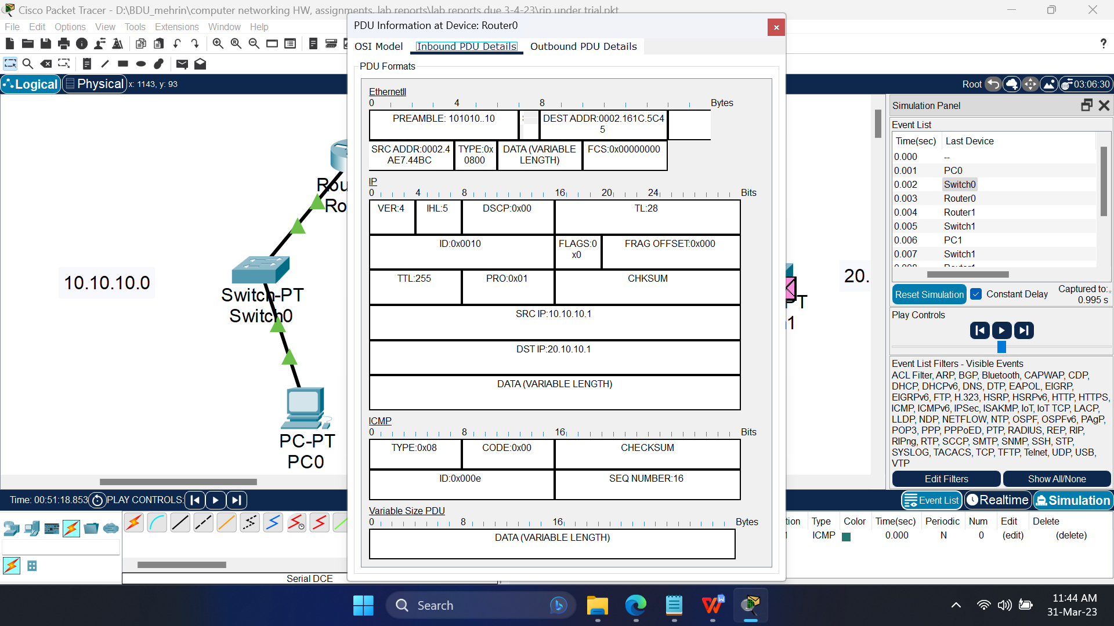

Fig 3.5: Inbound Protocol data unit details at Router0

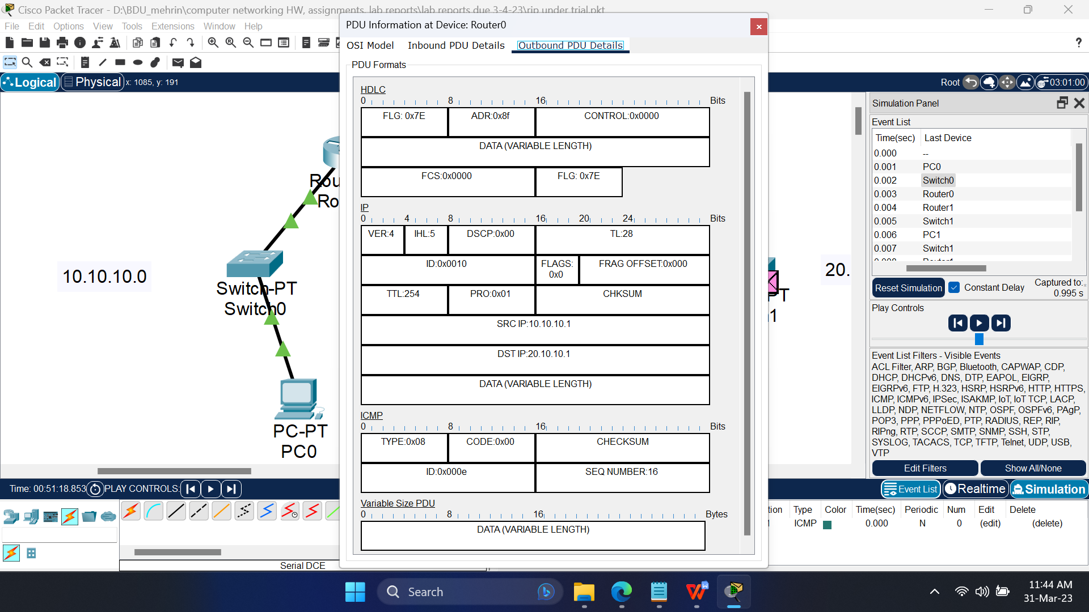

Fig 3.6: Outbound Protocol data unit details at Router0

**Conclusion:**

In RIP or Routing Information Protocol, only the network IPs are added, best route is calculated by the router.

**Experiment No.: 4**

**Experiment Title:** Redistribution between EIGRP and OSPF

**Objectives:**

* To learn how to configure redistribution between tow networks that are running on two different protocols
* How to configure routers using CLI

**Discussion:**

OSPF or Open Shortest Path First is a dynamic routing protocol of class ‘link-state routing protocol’.

EIGRP or Enhanced Interior Gateway Protocol is a routing protocol of class ‘distance vector routing protocol’.

Redistribution of EIGRP and OSPF refers to the process of sharing routing information between two different routing protocols.

**Methodology:**

* Create the network topology.
* Configuration of the Network Nodes.
* Choose the Statistics.
* Run the Simulation.
* Analysis of the Results.

**Working procedure:**

1. **Giving the geometric shape of the topology**

Connecting 4 PCs to 2 switches, 2 per each, and then connecting the 2 switches to 2 routers with straight through copper cable, as they are different typed devices.

Now, bring in a third router and then to connect the routers to it’s neighbouring router(s), at first we need to turn OFF the router to add “WIC-1T” network interfaces to connect the routers with “serial DCE (Data Communications Equipment)” cable. After adding “WIC-1T”, we turn ON the router.

The middle router will require two “WIC-1T” network interfaces

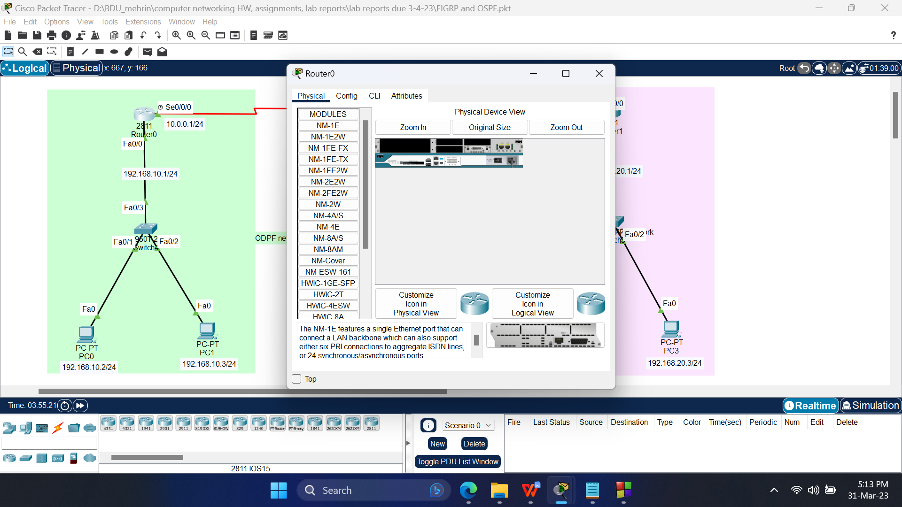

Fig 4.2: Rear view of the router after installing WIC-1T interface in CPT

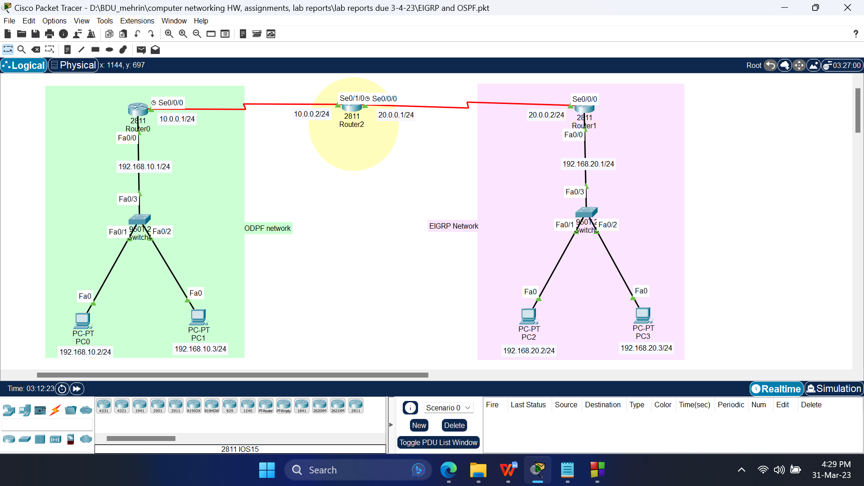

Fig 4.2: Simulating a mesh topology in CPT

1. **Configuring the devices**
   1. Configure the PCs with the following IP addresses and Subnet Masks

|  |  |  |  |
| --- | --- | --- | --- |
| **Host** | **IP Address** | **Subnet Mask** | **Default Gateway** |
| PC0 | 192.168.10.2 | 255.255.255.0 | 192.168.10.1 |
| PC1 | 192.168.10.3 | 255.255.255.0 | 192.168.10.1 |
| PC2 | 192.168.20.2 | 255.255.255.0 | 192.168.20.1 |
| PC3 | 192.168.20.3 | 255.255.255.0 | 192.168.20.1 |

* 1. Configure the routers with the following IP addresses and Subnet Masks

|  |  |  |  |
| --- | --- | --- | --- |
| **Host** | **Port** | **IP Address** | **Subnet Mask** |
| Router0 | FastEthernet0/0 | 192.168.10.1 | 255.255.255.0 |
| Serial0/0/0 | 10.0.0.1 | 255.0.0.0 |
| Router1 | FastEthernet0/0 | 192.168.20.1 | 255.255.255.0 |
| Serial0/0/0 | 20.0.0.2 | 255.0.0.0 |
| Router2 | Serial0/1/0 | 10.0.0.2 | 255.0.0.0 |
| Serial0/0/0 | 20.0.0.1 | 255.0.0.0 |

Commands pushed in the CLI (Command Line Interface),

Router0:

Router>enable

Router#configure terminal

Router(config)#interface fastethernet 0/0

Router(config-if)#ip address 192.168.10.1 255.255.255.0

Router(config-if)#no shutdown

Router(config-if)#exit

Router(config)#interface serial 0/0/0

Router(config-if)#ip address 10.0.0.1 255.255.255.0

Router(config-if)#clock rate 72000

Router(config-if)#no shutdown

Router(config-if)#exit

Router(config)#router ospf 1

Router(config-router)#network 10.0.0.0 0.0.0.255 area 0

Router(config-router)#exit

Router#copy running-config startup-config

Router1:

Router>enable

Router#configure terminal

Router(config)#interface fastethernet 0/0

Router(config-if)#ip address 192.168.20.1 255.255.255.0

Router(config-if)#no shutdown

Router(config-if)#exit

Router(config)#interface serial 0/0/0

Router(config-if)#ip address 20.0.0.2 255.255.255.0

Router(config-if)#no shutdown

Router(config-if)#exit

Router(config)#router eigrp 1

Router(config-router)#network 192.168.20.0 0.0.0.255

Router(config-router)#network 20.0.0.0 0.0.0.255

Router(config-router)#exit

Router#copy running-config startup-config

Router2:

Router>enable

Router#configure terminal

Router(config)#interface serial 0/1/0

Router(config-if)#ip address 10.0.0.2 255.255.255.0

Router(config-if)#no shutdown

Router(config-if)#exit

Router(config)#interface serial 0/0/0

Router(config-if)#ip address 20.0.0.1 255.255.255.0

Router(config-if)#clock rate 128000

Router(config-if)#no shutdown

Router(config-if)#exit

Router(config)#router ospf 1

Router(config-router)#network 10.0.0.0 0.0.0.255 area 0

Router(config-router)#exit

Router(config)#router eigrp 1

Router(config-router)#network 20.0.0.0 0.0.0.255

Router(config-router)#exit

Router(config)#router ospf 1

Router(config-router)#redistribute eigrp 1 subnets

Router(config-router)#exit

Router(config)#router eigrp 1

Router(config-router)#redistribute ospf 1 metric 1544 100 255 1 100

Router(config-router)#exit

Router(config)#exit

Router#copy running-config startup-config

1. **Sending data across PCs**
   1. Connection tests across PCs

Ping PCs by there IP addresses from another PC in Command Prompt. If connection is there, four replies will come.

Command: ping<space>’IP address of some other PC’

For first time communication, some packets may be lost.

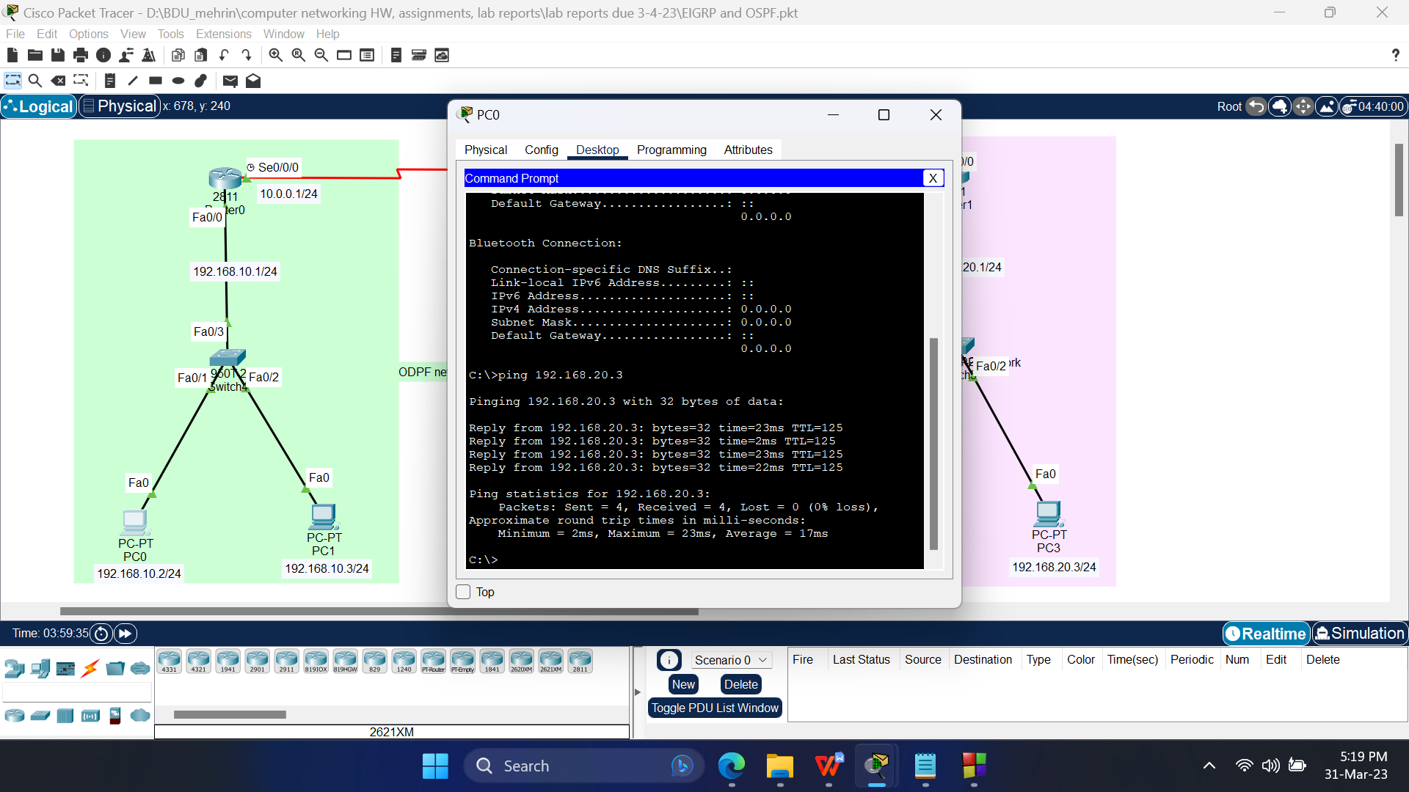

Fig 4.3: Pinging PC3 from PC0

1. **Simulation:**

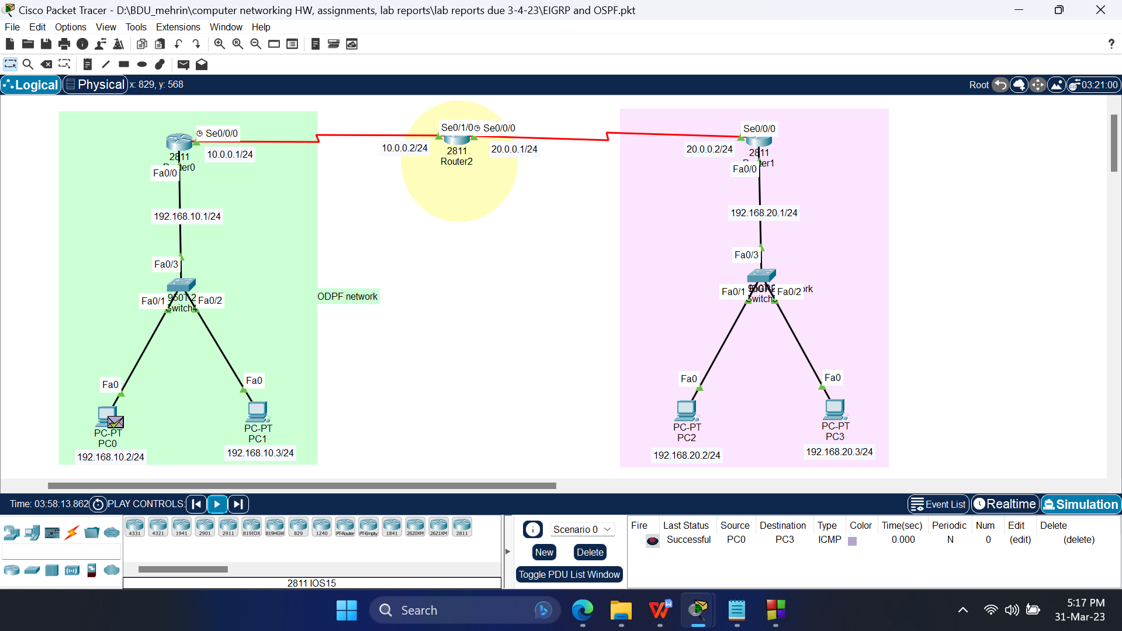

Fig 4.4: Successful packets travel across PCs

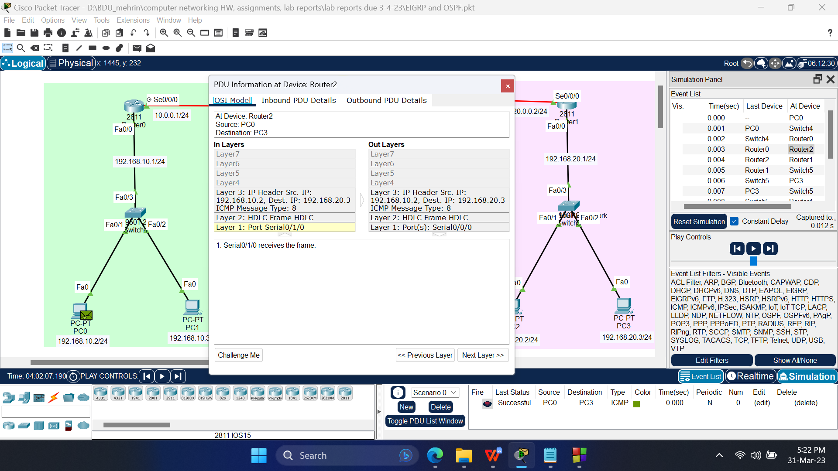

Fig 4.5: PDU information at the OSI model in Router0

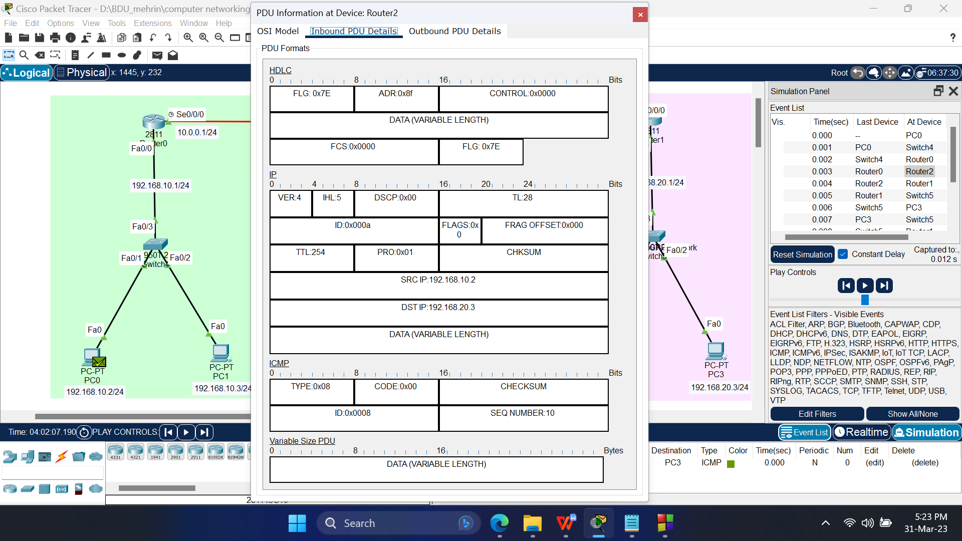

Fig 4.6: Inbound Protocol data unit details at Router0

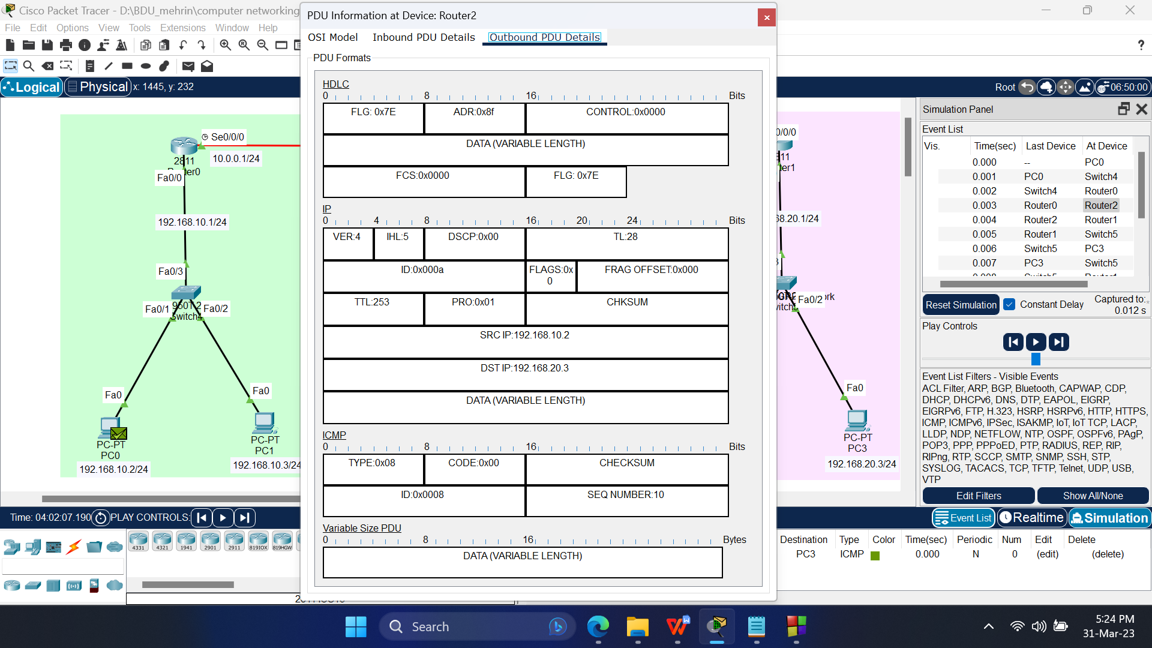

Fig 4.7: Outbound Protocol data unit details at Router0

**Conclusion:**

One other router is required to connect multiple networks of different protocols.

Caution:

* While configuring the serial ports of the routers, as they will be connected to different networks, just having different host part of the IP addresses will not work, it will still overlap with the other network. Therefore, the network part of the IP address must also be different.

**Lab Conclusion:**

From this lab we got to know about,

* Routing
* The process of selecting a path for traffic in a network or between multiple networks.
* Static routing
* A type of network routing that occurs when a router uses a manually-configured routing entry, rather than information from a dynamic routing traffic.
* Dynamic routing
* A process where a router can forward data via a different route for a given destination based on the current conditions of the communication circuits within a system.
* Routing Information Protocol
* A dynamic routing protocol that uses hop count as a routing metric to find the best path between the source and the destination network.
* Redistribution of routing protocols
* The process of sharing routing information between different routing protocols. It is used when multiple routing protocols are used in a network and it is necessary to share routing information between them